HORTICULTURE

TSÜNÜSEMPONGTSÜ MESEN NUNGI KÜMZÜKTSÜ ATEMA TAKÜM ALIBA AMSHIBA

Taküm aliba ajanga azüokba- Iba tetetzü ya mesen nungi kümzüka alitsü atema taküm alibatem (biological creatures or organisms) amshiba lir

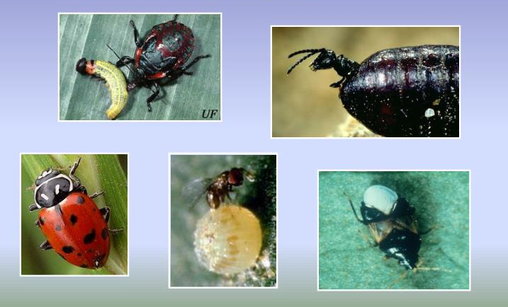
Mesen achiba shirurutem- Mesen agi meinba tesem nung mesen achiba shirurutem lidaktsütsü aser parnok
soyabokya taktsütsüla.
- Parnok talidak ki akatsü atema süngdong aser aitem alu meküta tsünütsüla.
- Tatishitsü : alu (frogs), kangrang (toads), koya mesükba shiruru tilaka (hedgehogs), koya, sanken nunger (moles), lah, ozütem, chameleons, longjangsangken (lizards), soraktem, meja, assassin bugs,black-kneed capsids, ninang, branchid wasps, parasitic wasps, dung beetles, ground beetles, tsüla, hawk moths, akotetsü merila (dragon flies), hoverflies, lacewings aser stick insects.
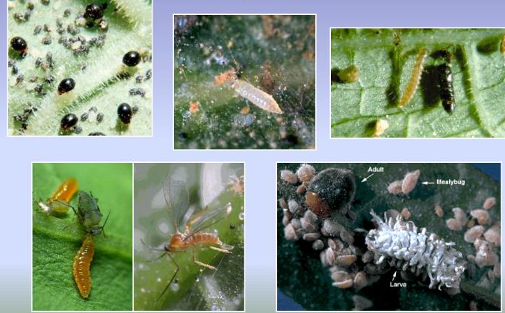
Mesen tepsetsü aliba mozü - Mesen agi chia tashidak adokbaji alu inyakba tashi agi menokdantetra, mesen tepsettsü mozü amshitsüji kanga nüngdak, lasüng, mersü, agi yangluba mesen tepsetba takaba mozü amala, itemya jenjang tasak masü saka iba ajanga mesen junga tepsetteter. Item tatishitsü kar:
  - Kitsüngsü naro tzü aser sapon meyokteba yangluba mozü. Iba tzü jagi alo, pingana, lolitem nung koba mesen agi achir aser tashidak adokdaktsür item nungi kümzüker.
  - Iba yagi mesen tila, longben aser mangatem südaktsür.
  - Lasüng tzü longben itemi alidak kalokjang, army worms, Colorado Beetle, False codling moth, Khapra beetle, Mexican bean beetle aser cabbage worms
- Ali nung lasüng tzü (garlic) meyokteba ajanga tsüla amala (nematodes) südaktsür.

Lokti-i kümzüka ayuba- Mesen tepsettsü atema temeküt aluyimertem den külemi teka amteper inyaktsüji nüngdak. Tatishitsü agi jangkok kobai alu raksatsür iba tesep tekong shia ka mesüra ana posa tena alir. Iba tepsetsü atema entsüji menüngsar anü nung konga südakja apur. Tesüpji tanger lu nungji alitsüja akok, saka iba jagi ner alu tena raksatsür. .

Tsünüsembongtsü tapu balala mesen agi raksatsüba nungi kümzüktsü atema biological ajanga inyakba

Biological Agents | Pest | Crop
Trichogrammabrassiliensis - 1.0 cc/ac. once in 10 days, (Egg parasitoid) | Lota/ shinü (Lepidopteran), Heliothissp | Pingana (Tomato)
Trichogrammachilonis - 2 cc/ac once in 15 days | Borers | Aonsotsü
Nuclear Polyhedrosis Virus (NPV) 100-200 LE/ac | Spodopterasp&Heliothissp | Aonsotsü
ChrysoperlaSp 5000 - 10000 eggs / ha, 3 - 4 times in 15 days, (Green lace wing) | Prudenia, Caterpillars,  White flies, thrips, aphids | Aonsotsü
Beauveriabassiana - 1.0% Affects the young stage, | Helicoperva, spodoptera, borers, hairy caterpillars, mites, scales, etc. | Aonsotsü, süngjanglijang
Phascilomycetes | Nematodes | Tsünüsempongtsü ajak
Bacillus thuringiensis var kustaki 0.3 - 0.4 % | Helicoperva, spodoptera, borers, hairy caterpillars, mites, scales, etc | Aonsotsü, süngjanglijang
NPV - Nuclear Polyhedrosis Virus of Spodoteralitura 250 – 500 ml/ ha 2 - 3 time at 10 days interval | Spodoteralitura | cabbage, mersü
NPV - Nuclear Polyhedrosis Virus of Helicoverpaarmigera 250 500 ml/ ha, 2 – 3 time at 10 days interval | Helicoverpaarmigera | cabbage, mersü

Aonsotsü atema Bio-Pesticides aser IPM Products

Pest/diseases | Biopesticides
Heliothis | Traps, lures, Bacillus Thuringiensis (BT, Nuclear Polyhedrosis Viruses (NPV), Trichogramma
Mites | Trichoderma, Pseudomonas
Fruit borer | Traps, lures, BT,NPV, Trichogramma
Mites | Neem 1500 ppm, verticillium

