ANIMAL HUSBANDRY: FEED & FODDER

Ak aser an metsütsü asoshi Azolla tsünüba
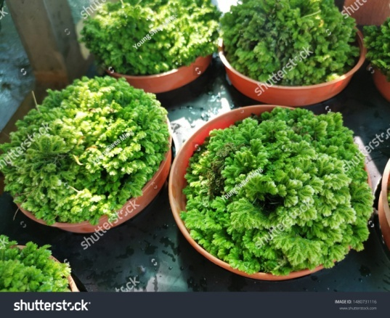
Azolla ya ak aser an metsütsü asoshi protein aika aliba asangdong ka lir. Ibai kidang melamela tsünütsü akoker aser jenjang tasak oil cakes/dokan feeds melen amshitsü asoshi
protein aliba chiyongtsü lir. Ali temo junga alitsü asoshi tsük lu nunga azolla ya tsünür.

Azolla tsünüba aser anepaluba

Tesem: Tera akhümpok aser tzü peria aliba tesem.

Tzüpu Size: 6 feet (L) x 4 feet (W) x 1 foot (depth), anogo shia approximate agi Azolla 600 g tashi bendentsü asoshi.

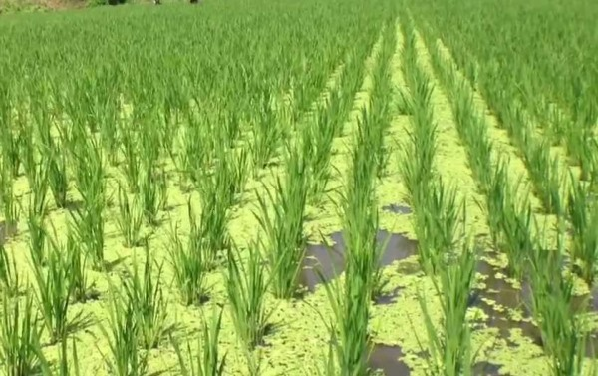
Osettem: Plastic sheets, plastic nets, side wall asoshi lungro aser cement.
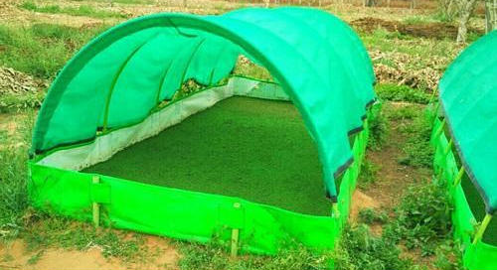
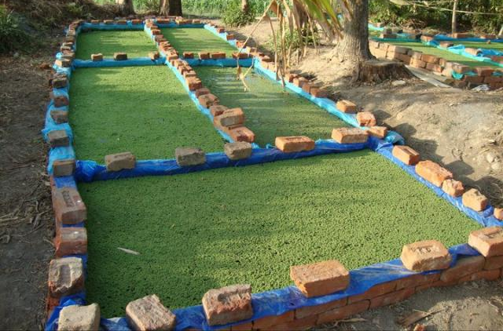

Inyakyim:
- 6 feet (L) x 4 feet (W) x 1 foot (depth) tasazük tzüpu tuang.
- (Noksa nung tuyua aliba ama) ita-lung aser silpauline sheet temelem agi rectangular mesükba nung tasazük kasa melentepa yanglur külen ano ka süli ta asütsüla. Idagi ali atutsü menüngdaker.
- Plastic sheet nungji ali temo alibaji kg 12-14 tashi prokang.
- Inches 6 tashi tarok tur tzü inokang.
- Tsüzüker anogo ishika aliba nashi scü kg 2 shi tzü tera nung meyoktepa tzüpu nungji inoka meyokteptsüla.
- Azolla 1/2 -1 kg shi tanemi pensa/balala kümdakja tzüpu nungji prokang.

Bendenba:
Hopta ana tashi nung asenoki Azolla 600 g tashi bendentettsü (2/3rd of the total). Anünga aliba 1/3 bendenloka aser taruba anogo nungji bendentsü akok. Asenoki anogo shia Azollaji 600 g bendentettsü.

Feeding: Azollaji tzü nung shidokang aser kisüngji chidakjang mesüra concentrated feed meyoktepang. Iba ya konga yur agütsütsü akoktsü.

Anepaluba:
- Hopta ana shia (Tatishitsü: Nashi scü tanük kg 1 tzü nung meyokteper) Nutrient mixture inokba.
- Ita 6-8 tashi nung tzüpuji meshimeshia azüngtetang aser tasen tenzükshiang.

