SCIENTIFIC YIMYA NUNG SEN AIKA MEINTOKI YANGLUBA AK KI
(SCIENTIFIC PIG HOUSE)
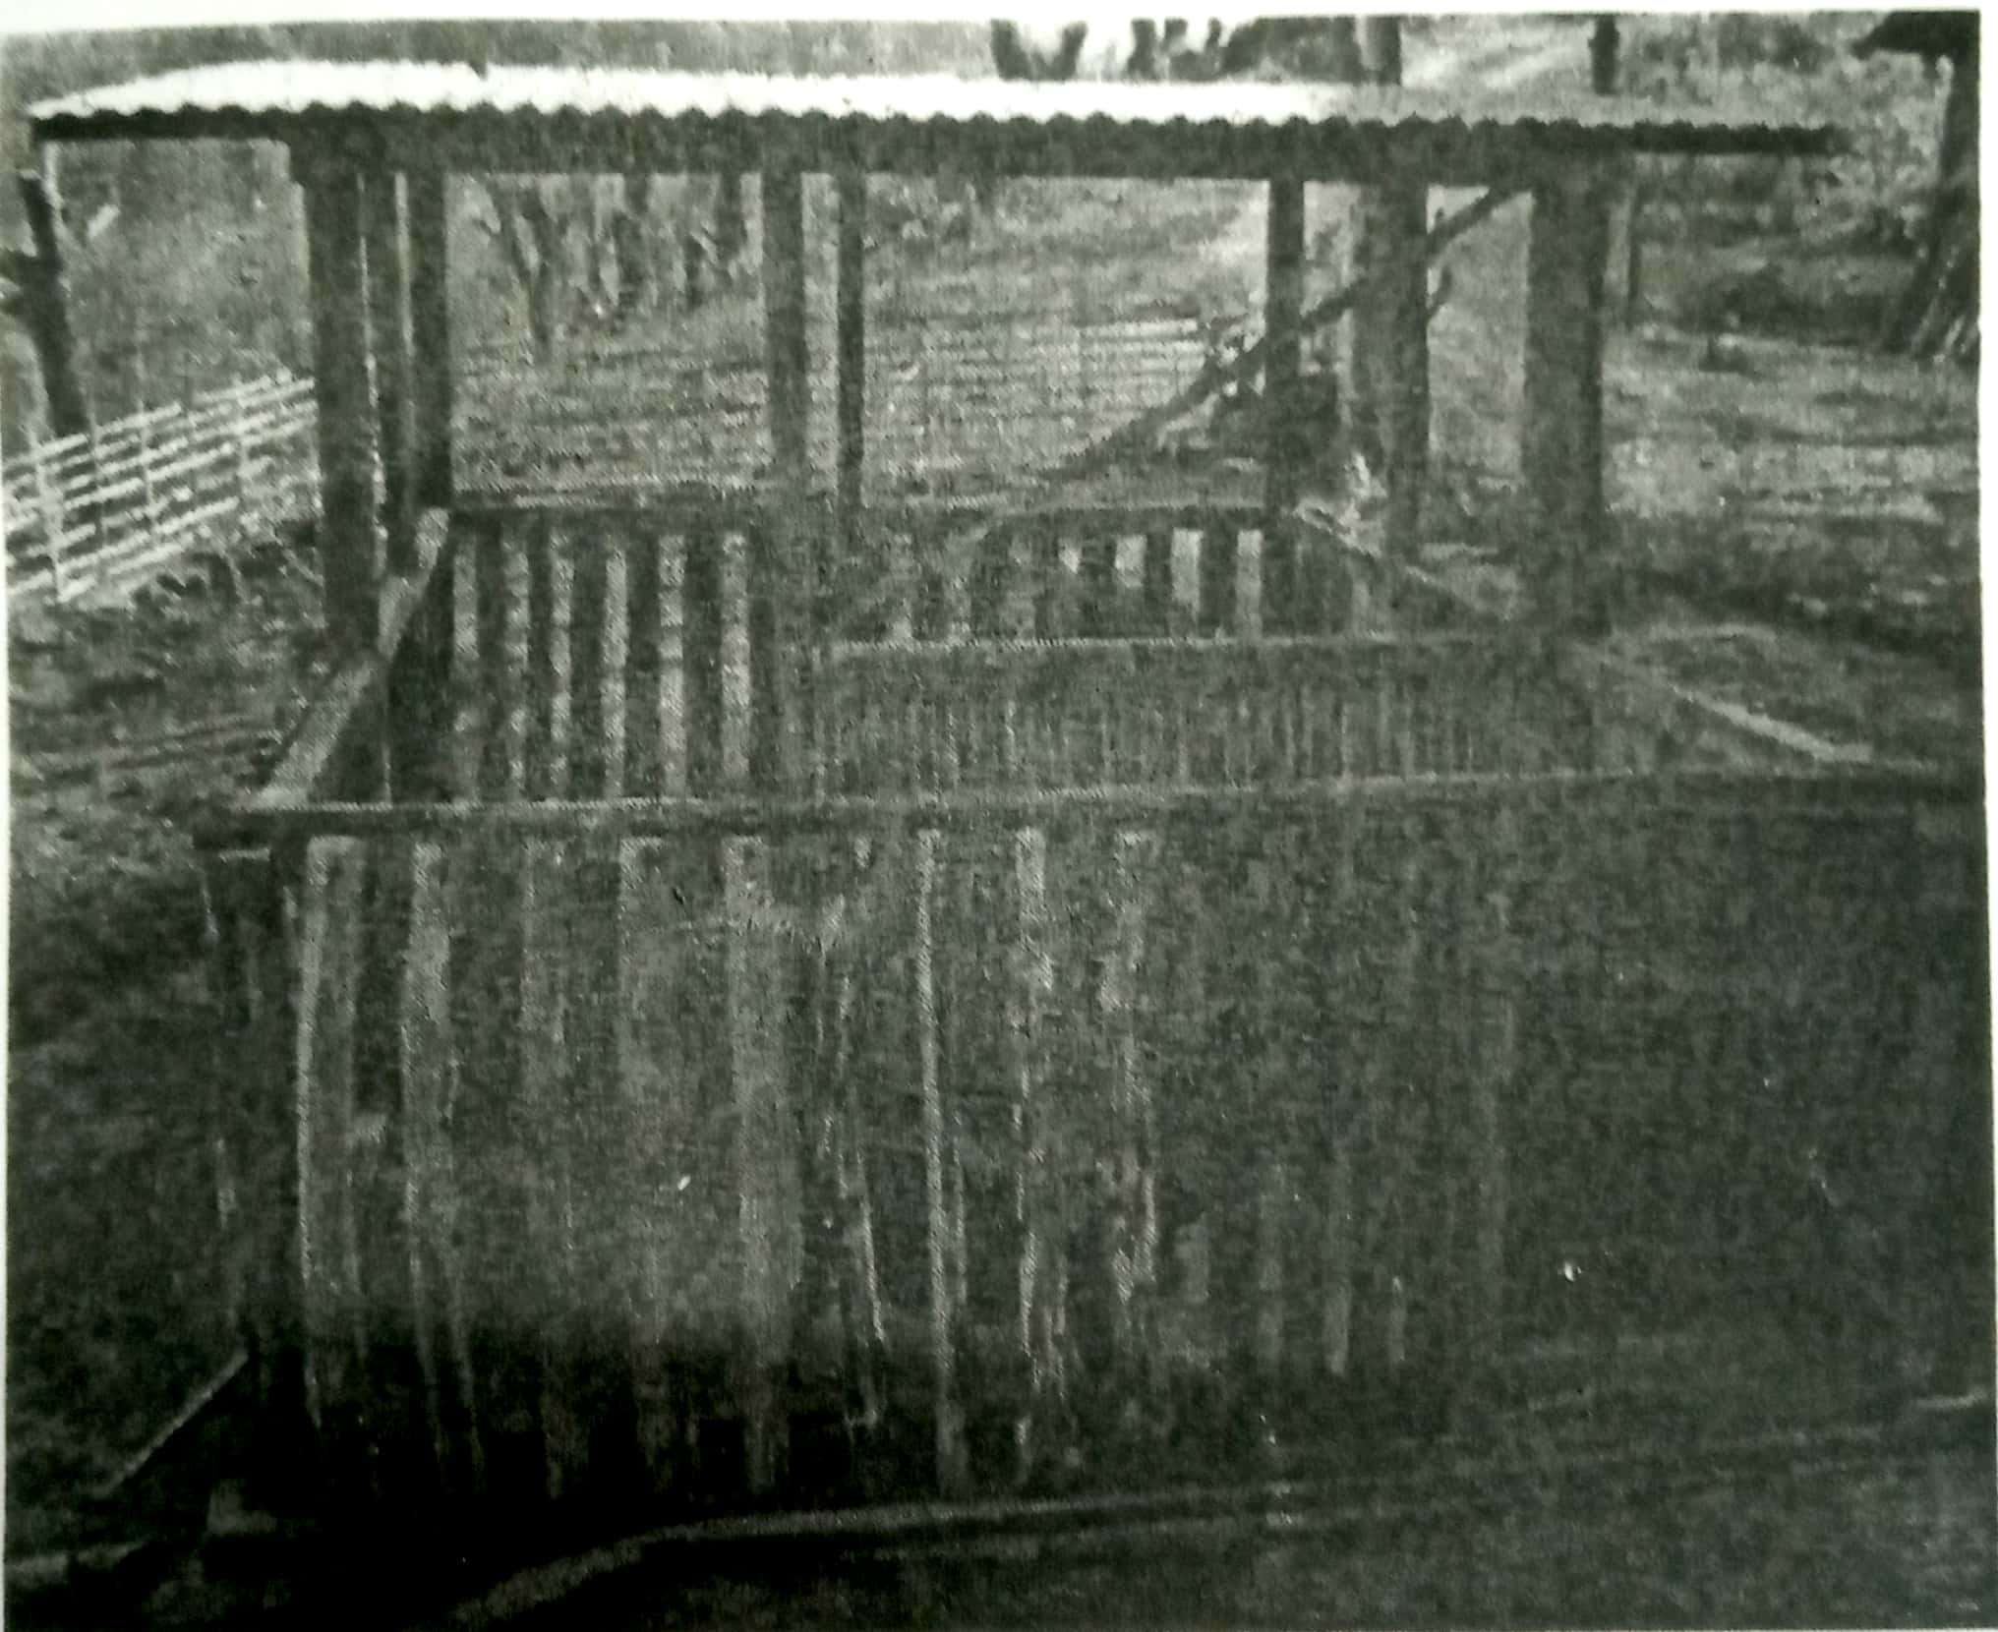

- Scientific Ak ki nungbo Rs. 1.34 lakhs aotsὓ saka teti amshia aruba Ak ki (conventional rural pig house)nungbo Rs. 3,500 dang adoktsὓ.
- Teti amshia aruba Ak ki yanglutsὓ temela saka talang ka malir.
- Anungji sen aika meintoki (low-cost scientific) Ak ki yangluba tajungba.
- Temokong nungi kümzuktsü atema aki ki atem ji sung mesura aou agi yanglutsüla.
- Sen aika meintoki yangluba Scientific Ak ki nung ji Rs. 17,000 aotsὓ.

Koma sen aika meintoki Scientific Ak ki yanglutsu.
- lenden motong asameyangdang anὓ-toklen aser anu-aolen repranga yanglubaji tajungba.
- Cement agi yangluba atem tasazὓkji 16 feet x 8 feet asütsüla, Kilemji 8 feet x 8 feet yinjong (C.G.I sheet) agi tongpangtsüla.
- Yinjong agi metongjemba tawa ji parnok asoshi anὓ awangtsὓ aser jana endokdak asutsὓla
- Ak ki atem wapetji 4-6% kilentzὓ aolen ongken ana ali tomu atema tua ayutsὓ aser ibaji kodang ka sungdir ka ji amshitettsὓ.
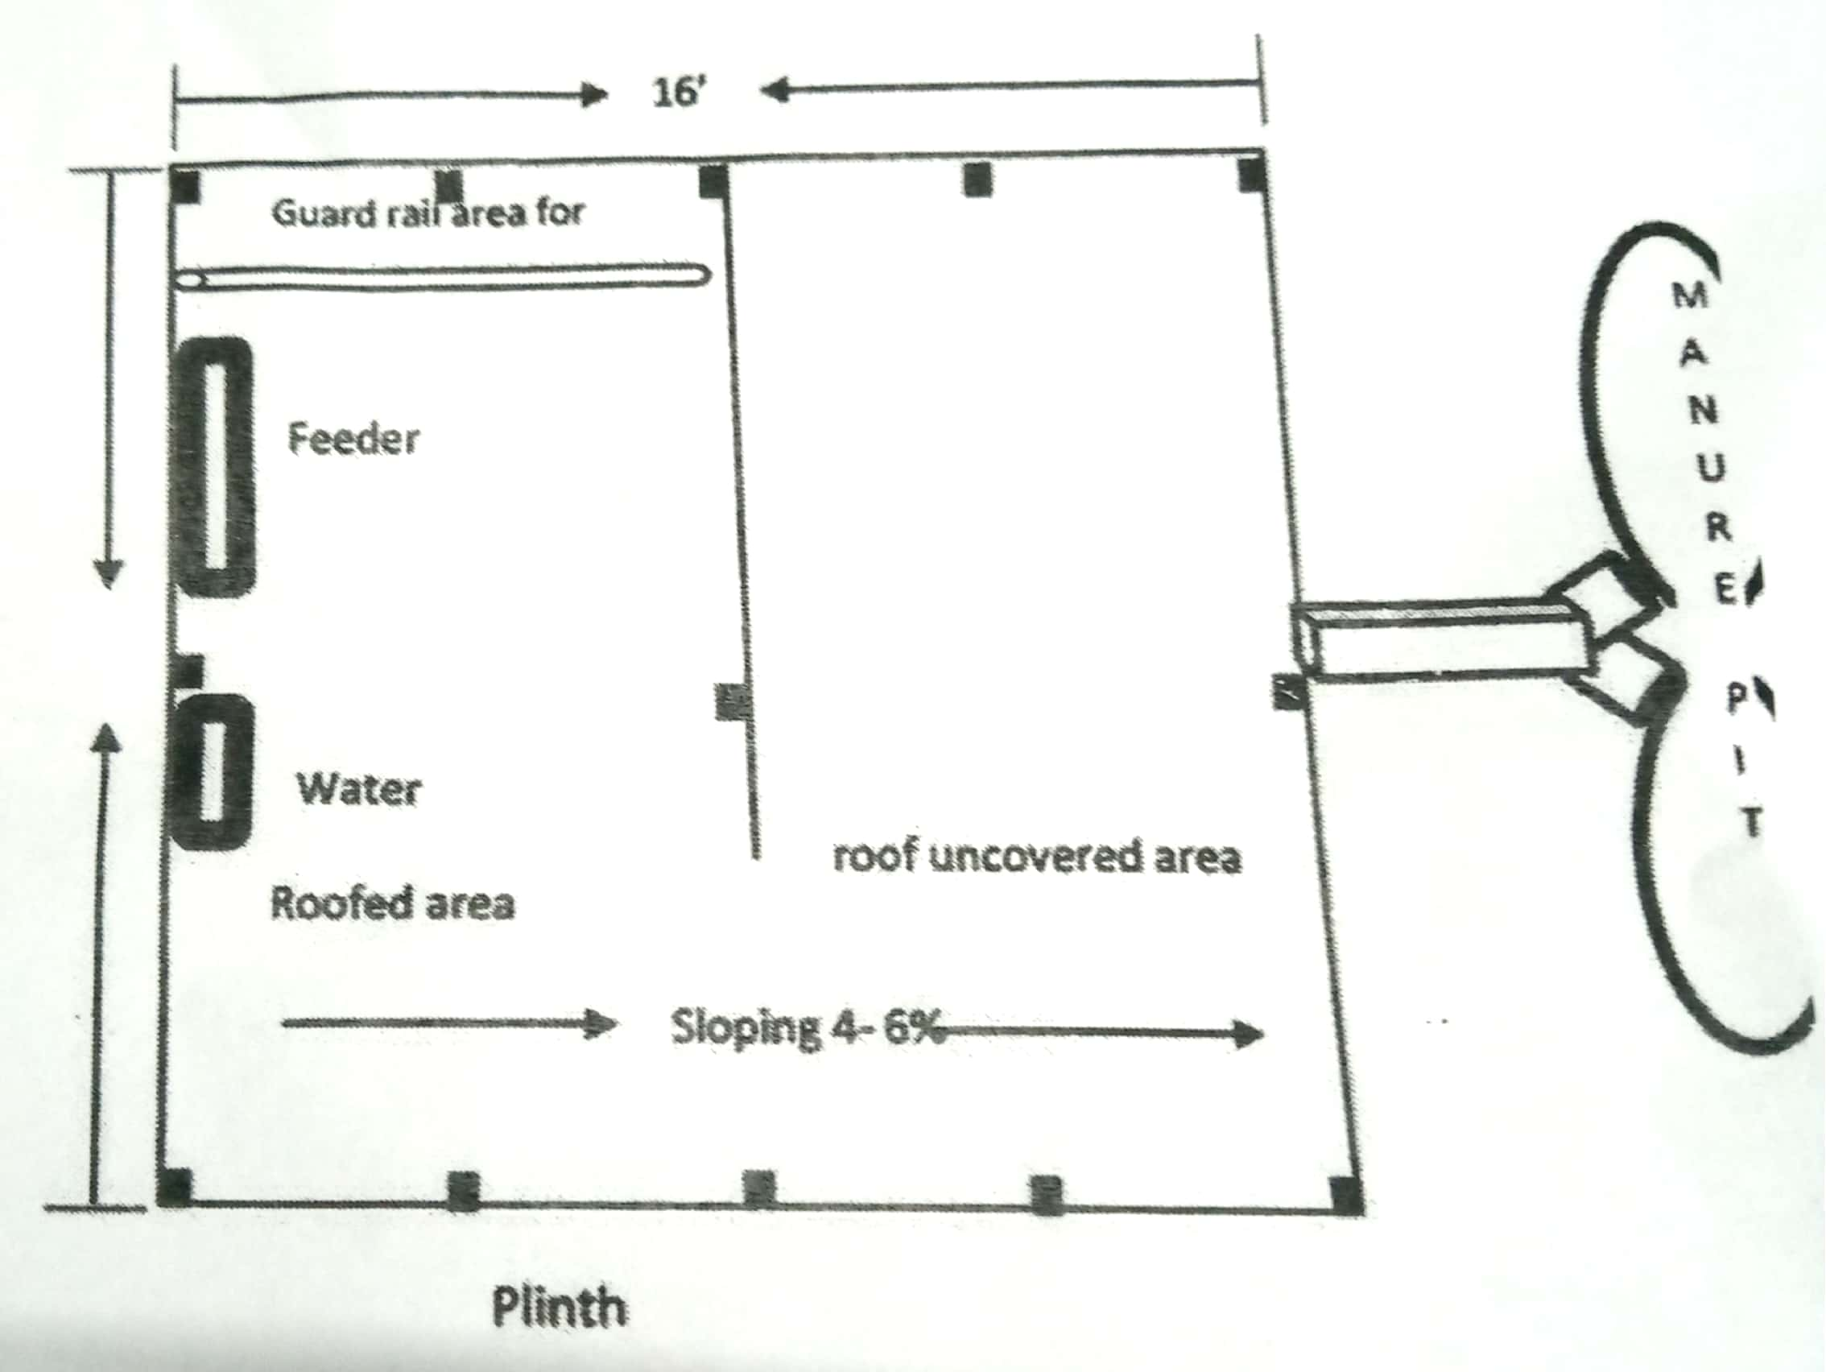

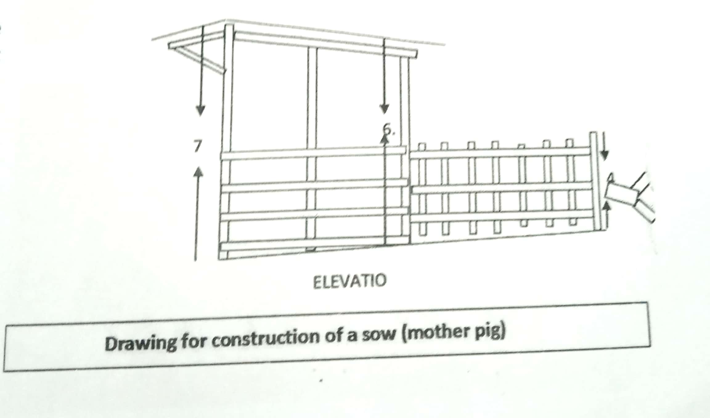

Ak techanu mepotang ayutsὓ ki yangluba

- Chiyongtsὓ aser tzὓ agutsὓtsὓ atema cement agi supanger alidak tejaklen yanglutsὓla.
- Sung aser au koba talangka meraksai alir ibaji amshia yangluba tajungba.
- Ak chanu inoka ayutsὓ atema Ak ki tezὓ len sὓng agi yangluba takdang nungji talem agutsü atema electricity amshitsὓ akok (light bulb or electricity heating)
- Ak techanu tetsüdang nungi kmüzüka alitsü atema Ak ki tezulen inch 10 ajungketer G.I pipe sudanga atongtsὓla aser inch 6 mesura 7 atemtsula kong Ak chanutemji mejangdaktsutsu. Iba ajanga tetsu arakzua aser mejangdang techanu meyurutsu aser metepsetsu.

